**COMP1021 Intro to Web Technologies**

**Coursework 1**

**OFF TEMPO Website**

**WIREFRAME MODELS:**

Home Page – index.html

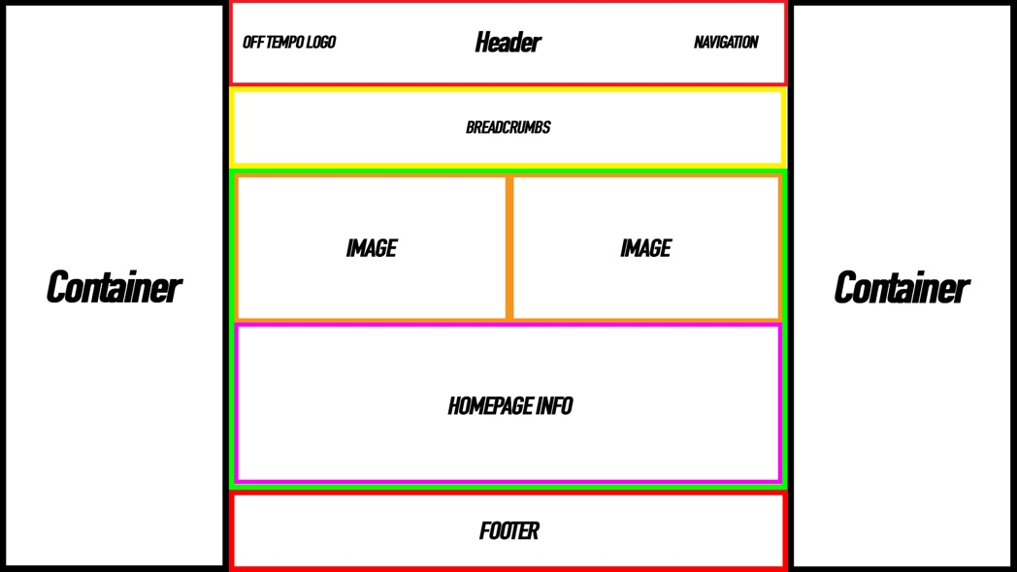

About Page – about.html

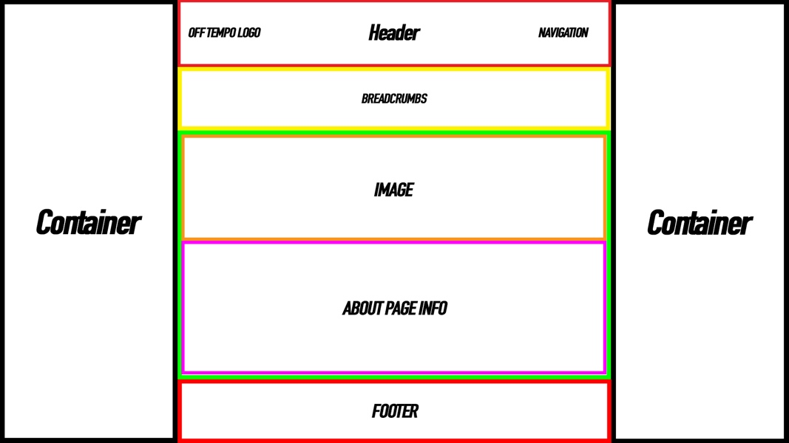

DJ/Producers Page – dj.html

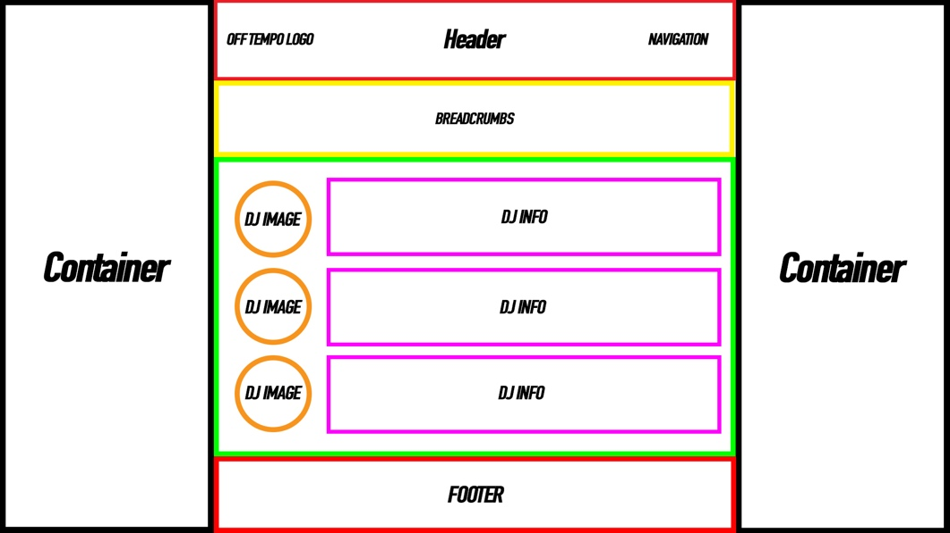

Media Page – media.html

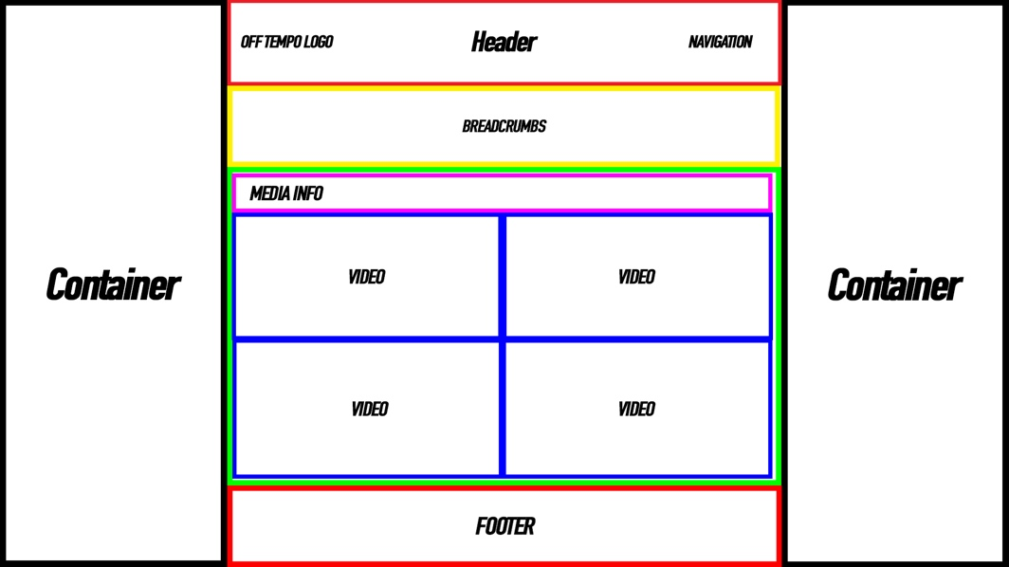

Events Page – events.html

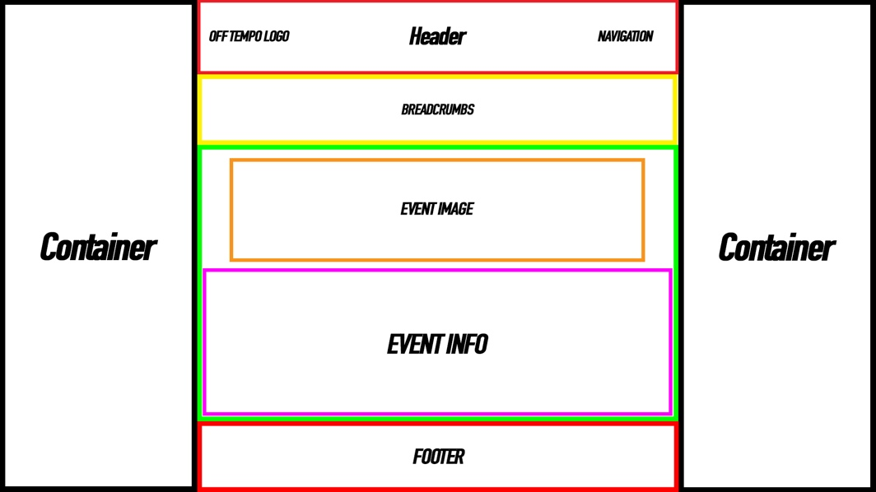

Contact Page – contact.html

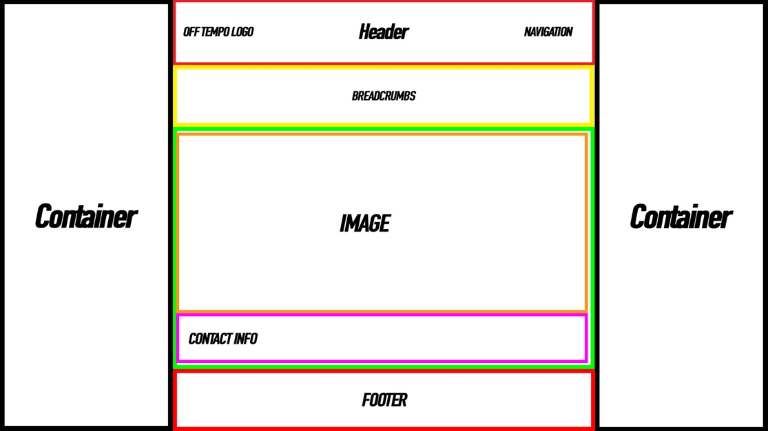

**COLOUR SCHEME & FONTS USED:**

Fonts Used:

Oswald, Josefin+Slab

 

Colour Scheme:

The overall colour scheme is a mixture of dark greys, blacks and whites. As well as variations on each page to assign it page a colour. This comes in the form of bottom borders under each link in the navigation bar. As well as a different colour circle in the breadcrumbs section, underneath the header. This gives each page a unique identifier and it looks good.

Header Colour: #1F1F1F

Breadcrumbs Colour: #000

Body Colour: #D7D7D7

Footer Colour: #333

Text Colours: #FFF, #000

Home Page Variation Colour: #44AF69

About Page Variation Colour: #F8333C

DJ Page Variation Colour: #1B5299

Media Page Variation Colour: #FCAB10

Events Page Variation Colour: #2B9EB3

Contact Page Variation Colour: #DBD5B5

**LAYOUT CHOICE & JUSTIFICATION/COMPARISON TO OTHER WEBSITES:**

Layout:

I’m believe my choice of layout for the website is a pretty standard way of laying out modern websites. It has a header at the top containing the logo & navigation links. It then has breadcrumbs and a little title below the header. The content of the page is below the breadcrumbs and when then content ends, the footer is at the bottom of the page.

This layout is good as it allows for expansion. For example, I could make it so when the user scrolls past a certain point on the page the header goes a little transparent and is fixed to the top of the page, allowing the user to access the navigation bar whilst lower down the page. I could also add more dynamic content and things like background videos which auto-play with the sound muted to create an interesting visual instead of just a plain background.

My layout is also easily transferrable to a responsive design, some elements already use media queries to adapt to the user browser, however for the next implementation I will make the website fully responsive using the bootstrap framework, as well as adding more dynamic content and other handy and effective HTML5 elements.

To expand my website for Coursework 2, I’ve drawn inspiration from the ABODE records website. <http://aboderecords.com/>

I plan to have a full browser window carousel like the one below which showcases Off Tempo. As well as a sticky header which stays at the top of the browser window regardless of where along the page the user is. I also plan to add some kinetic effects using the transform property in CSS, this creates a more visually pleasing website as everything isn’t still.



**EVALUATION OF MY IMPLEMENTATION:**

Overall, I think my initial implementation and my final product are quite similar. The implementation is good for a basic implementation and has lots of room to grow using other features which HTML & CSS have to offer. This can be refined more in Coursework 2. The information is appropriate alongside images used on the different pages. More pictures and videos can be added to the media page and the DJ page can be changed to be more interactive by using hover properties over images to display the DJ name instead of it just being to the right of the image; mixes can also be to the DJ page to showcase each DJ’s mixing style to give the user an idea of what to expect at an Off Tempo event.

I think my initial design matched my implementation quite well, images and links are in the same places as the wireframe models and the design is consistent across the different pages.

**TESTS:**

|  |  |  |  |
| --- | --- | --- | --- |
| **ELEMENT** | **IMAGE** | **TEST TO DO** | **WORKS OR NOT** |
| **Home Link – Home Page** |  | **Test if link works and is active** | **YES** |
| **About Link – Home Page** |  | **Test if link works** | **YES** |
| **DJ/Producer Link – Home Page** |  | **Test if link works** | **YES** |
| **Media Link – Home Page** |  | **Test if link works** | **YES** |
| **Events Link – Home Page** |  | **Test if link works** | **YES** |
| **Contact Link – Home Page** |  | **Test if link works** | **YES** |
| **Facebook Link Footer – Home Page** |  | **Test if link works** | **YES** |
| **Soundcloud Link Footer – Home Page** |  | **Test if link works** | **YES** |
| **Email Mailto Link Footer – Home Page** |  | **Test if link works** | **YES** |
| **Home Link – About Page** |  | **Test if link works** | **YES** |
| **About Link – About Page** |  | **Test if link works and is active** | **YES** |
| **DJ/Producer Link – About Page** |  | **Test if link works** | **YES** |
| **Media Link – About Page** |  | **Test if link works** | **YES** |
| **Events Link – About Page** |  | **Test if link works** | **YES** |
| **Contact Link – About Page** |  | **Test if link works** | **YES** |
| **Facebook Link Footer – About Page** |  | **Test if link works** | **YES** |
| **Soundcloud Link Footer – About Page** |  | **Test if link works** | **YES** |
| **Email Mailto Link Footer – About Page** |  | **Test if link works** | **YES** |
| **Home Link – DJ Page** |  | **Test if link works** | **YES** |
| **About Link – DJ Page** |  | **Test if link works** | **YES** |
| **DJ/Producer Link – DJ Page** |  | **Test if link works and is active** | **YES** |
| **Media Link – DJ Page** |  | **Test if link works** | **YES** |
| **Events Link – DJ Page** |  | **Test if link works** | **YES** |
| **Contact Link – DJ Page** |  | **Test if link works** | **YES** |
| **Facebook Link Footer – DJ Page** |  | **Test if link works** | **YES** |
| **Soundcloud Link Footer – DJ Page** |  | **Test if link works** | **YES** |
| **Email Mailto Link Footer – DJ Page** |  | **Test if link works** | **YES** |
| **Home Link – Media Page** |  | **Test if link works** | **YES** |
| **About Link – Media Page** |  | **Test if link works** | **YES** |
| **DJ/Producer Link – Media Page** |  | **Test if link works** | **YES** |
| **Media Link – Media Page** |  | **Test if link works and is active** | **YES** |
| **Events Link – Media Page** |  | **Test if link works** | **YES** |
| **Contact Link – Media Page** |  | **Test if link works** | **YES** |
| **Facebook Link Footer – Media Page** |  | **Test if link works** | **YES** |
| **Soundcloud Link Footer – Media Page** |  | **Test if link works** | **YES** |
| **Email Mailto Link Footer – Media Page** |  | **Test if link works** | **YES** |
| **Home Link – Events Page** |  | **Test if link works** | **YES** |
| **About Link – Events Page** |  | **Test if link works** | **YES** |
| **DJ/Producer Link – Events Page** |  | **Test if link works** | **YES** |
| **Media Link – Events Page** |  | **Test if link works and is active** | **YES** |
| **Events Link – Events Page** |  | **Test if link works and is active** | **YES** |
| **Contact Link – Events Page** |  | **Test if link works** | **YES** |
| **Facebook Link Footer – Events Page** |  | **Test if link works** | **YES** |
| **Soundcloud Link Footer – Events Page** |  | **Test if link works** | **YES** |
| **Email Mailto Link Footer – Events Page** |  | **Test if link works** | **YES** |
| **Home Link – Contact Page** |  | **Test if link works** | **YES** |
| **About Link – Contact Page** |  | **Test if link works** | **YES** |
| **DJ/Producer Link – Contact Page** |  | **Test if link works** | **YES** |
| **Media Link – Contact Page** |  | **Test if link works and is active** | **YES** |
| **Events Link – Contact Page** |  | **Test if link works and is active** | **YES** |
| **Contact Link – Contact Page** |  | **Test if link works** | **YES** |
| **Facebook Link Footer – Contact Page** |  | **Test if link works** | **YES** |
| **Soundcloud Link Footer – Contact Page** |  | **Test if link works** | **YES** |
| **Email Mailto Link Footer – Contact Page** |  | **Test if link works** | **YES** |
| **First Video Works – Media Page** |  | **Test if video plays or not** | **YES** |
| **Second Video Works – Media Page** |  | **Test if video plays or not** | **YES** |
| **Third Video Works – Media Page** |  | **Test if video plays or not** | **YES** |
| **Fourth Video Works – Media Page** |  | **Test if video plays or not** | **NO (Video was unable to be embedded from FB)** |
| **Test Ticket Link – Events Page** |  | **Test if ticket link works** | **YES** |
| **Test Message FB Page Link – Contact Page** |  | **Test if FB page link works** | **YES** |

**REFERENCES:**

|  |  |  |  |
| --- | --- | --- | --- |
| **IMAGE** | **IMAGE DESC** | **IMAGE LINK** | **OWNERSHIP/**  **RIGHTS** |
| images/OffTempoDistrikt.jpg | **Off Tempo Distrikt Event Headline, Jordan Magee** | [**https://scontent-lhr3-1.xx.fbcdn.net/v/t1.0-9/16266107_236435453480712_7290962527707922934_n.jpg?oh=0318a07c374504b13738c5f40b4e8e6e&oe=59701CB6**](https://scontent-lhr3-1.xx.fbcdn.net/v/t1.0-9/16266107_236435453480712_7290962527707922934_n.jpg?oh=0318a07c374504b13738c5f40b4e8e6e&oe=59701CB6) | **YES** |
| **images/OffTempoLogo.jpg** | **Off Tempo Facebook Logo** | [**https://scontent-lhr3-1.xx.fbcdn.net/v/t1.0-9/15621687_216099015514356_1194969174827411550_n.jpg?oh=108351905a7c802ffe2a8143f637d472&oe=59334B31&dl=1**](https://scontent-lhr3-1.xx.fbcdn.net/v/t1.0-9/15621687_216099015514356_1194969174827411550_n.jpg?oh=108351905a7c802ffe2a8143f637d472&oe=59334B31&dl=1) | **YES** |
| **images/logo.png** | **OFF TEMPO logo** | **Self-Owned** | **YES** |
|  | **We Are. Nights Logo** | [**https://scontent-lhr3-1.xx.fbcdn.net/v/t1.0-9/15622387_1820492374899143_8775193705989135427_n.jpg?oh=a2032310a8a2810f5e15922d3ce5a391&oe=59676C34**](https://scontent-lhr3-1.xx.fbcdn.net/v/t1.0-9/15622387_1820492374899143_8775193705989135427_n.jpg?oh=a2032310a8a2810f5e15922d3ce5a391&oe=59676C34) | **YES** |
| **images/offtempoevent.jpg** | **Off Tempo Distrikt advert.** | [**https://scontent-lhr3-1.xx.fbcdn.net/v/t1.0-9/15672901_215718615552396_3804296873138828821_n.jpg?oh=acfa02556ebba0f803bf4174ccfe5041&oe=5971DD10**](https://scontent-lhr3-1.xx.fbcdn.net/v/t1.0-9/15672901_215718615552396_3804296873138828821_n.jpg?oh=acfa02556ebba0f803bf4174ccfe5041&oe=5971DD10) | **YES** |
| **images/ash.jpg** | **Eastyy DJ Image** | [**https://scontent-lhr3-1.xx.fbcdn.net/v/t1.0-9/15095546_10211040296467054_2240645459512560579_n.jpg?oh=2184c917212c4d91f8112ea23a07102a&oe=59256670**](https://scontent-lhr3-1.xx.fbcdn.net/v/t1.0-9/15095546_10211040296467054_2240645459512560579_n.jpg?oh=2184c917212c4d91f8112ea23a07102a&oe=59256670) | **YES** |
| **images/haneylee.jpg** | **Haney Lee DJ Image** | [**https://scontent-lhr3-1.xx.fbcdn.net/v/t1.0-9/16002781_1208584035921917_8012146044799668564_n.jpg?oh=4653fe590779fc368954694296365500&oe=596538EB**](https://scontent-lhr3-1.xx.fbcdn.net/v/t1.0-9/16002781_1208584035921917_8012146044799668564_n.jpg?oh=4653fe590779fc368954694296365500&oe=596538EB) | **YES** |
| **images/hennessey.jpg** | **Hennessey DJ Image** | [**https://scontent-lhr3-1.xx.fbcdn.net/v/t1.0-9/12814559_1020631301355277_4379256243294133516_n.jpg?oh=71f43381f450bde9090e45d4f59683e7&oe=592A9EC9**](https://scontent-lhr3-1.xx.fbcdn.net/v/t1.0-9/12814559_1020631301355277_4379256243294133516_n.jpg?oh=71f43381f450bde9090e45d4f59683e7&oe=592A9EC9) | **YES** |
| **images/ETHOS.jpg** | **ETHOS Freedom Mills Event Image** | [**https://scontent-lhr3-1.xx.fbcdn.net/v/t1.0-9/17022510_1853186421629738_8650717907768281402_n.jpg?oh=b20d142492b8a4492a3ebd15180a2b1f&oe=59334273**](https://scontent-lhr3-1.xx.fbcdn.net/v/t1.0-9/17022510_1853186421629738_8650717907768281402_n.jpg?oh=b20d142492b8a4492a3ebd15180a2b1f&oe=59334273) | **YES** |
| **images/ash-distriktbar.jpg** | **Ash Contact Image** | [**https://scontent-lhr3-1.xx.fbcdn.net/v/t1.0-9/16142476_10211698098391691_4061790849108040476_n.jpg?oh=b68c3ce3a23ac74a2186b3fafd76ef30&oe=5930FA3C**](https://scontent-lhr3-1.xx.fbcdn.net/v/t1.0-9/16142476_10211698098391691_4061790849108040476_n.jpg?oh=b68c3ce3a23ac74a2186b3fafd76ef30&oe=5930FA3C) | **YES** |